ATM Demo App - Screenshots

## By: Nihar Pandya

Contents

By: Nihar Pandya 1

Home Page: 1

After Login Successful: 2

Withdraw: 3

Withdraw Successful: 4

Deposit: 5

View Current Balance: 6

## Home Page:

## After Login Successful:

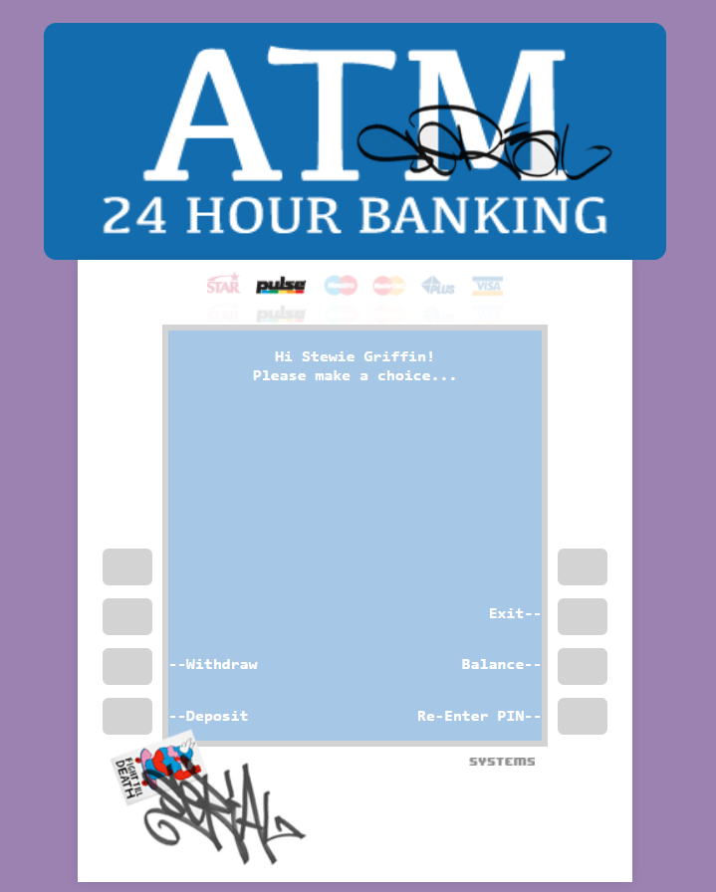

## Withdraw:

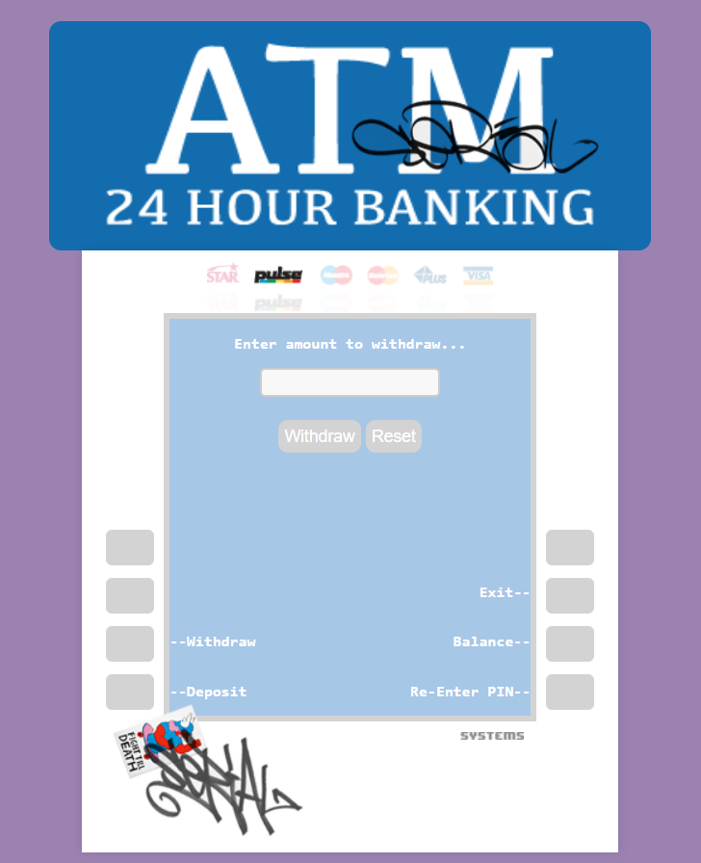

## Withdraw Successful:

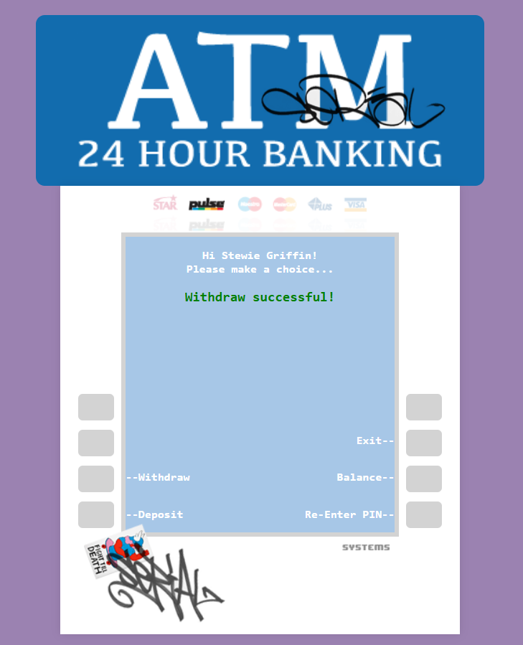

## Deposit:

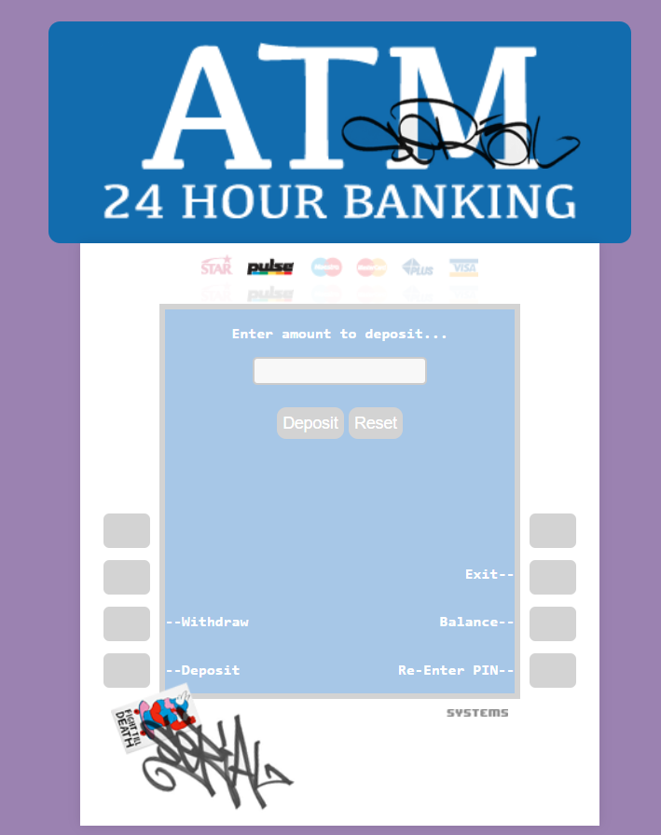

## View Current Balance:

